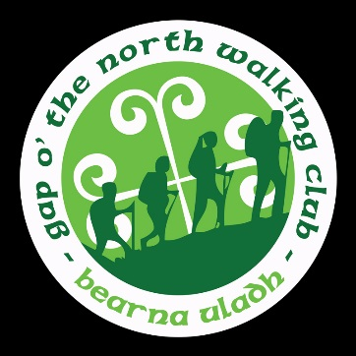

Gap o’ the North Hill Walking Club
Come join us for a Festive Family Ramble on
Sunday 29th of December
(Registration from 11.30am)
All are welcome
So get your Santa Boots and Christmas Hat and join us for some festive fitness and fun,
Then back to the Gap for entertainment
From afternoon to late at night!!
(Bring a packed lunch and waterproof jacket)
You’d never know who you might meet,
Ho, Ho, Ho!!!!!

